Advanced Database Training
2026
Vaishnavi Kamthe

Assignment 2b
1. Find all records having attribute_value beginning with ‘p’ only (it should not contain the records beginning with ‘P’).
SELECT *
FROM products
WHERE attribute_value REGEXP '^p';
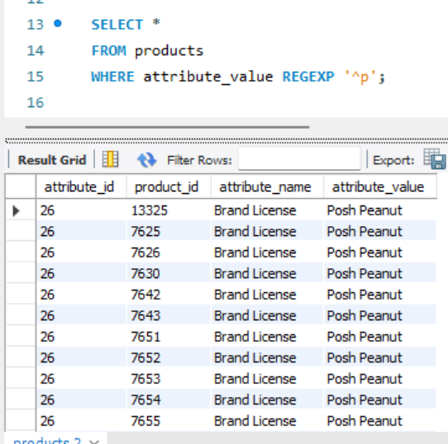
2. Find all records having attribute_value ending with ‘on’.
SELECT * FROM products
WHERE attribute_value REGEXP 'on$';
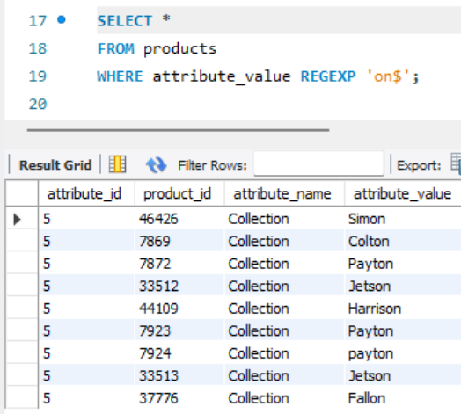
3. Find product_id and attribute_value for the records in which atrribute_name contains characters from ‘a’ to ‘c’.
SELECT product_id, attribute_value FROM products
WHERE attribute_name REGEXP '[a-c]';
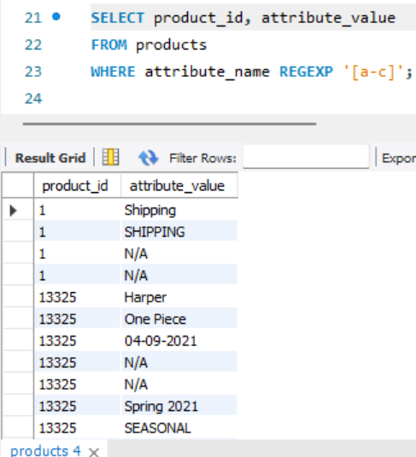
4. Find all records whose value starts with character G, M or S.
SELECT *
FROM products
WHERE attribute_value REGEXP '^[GMS]';
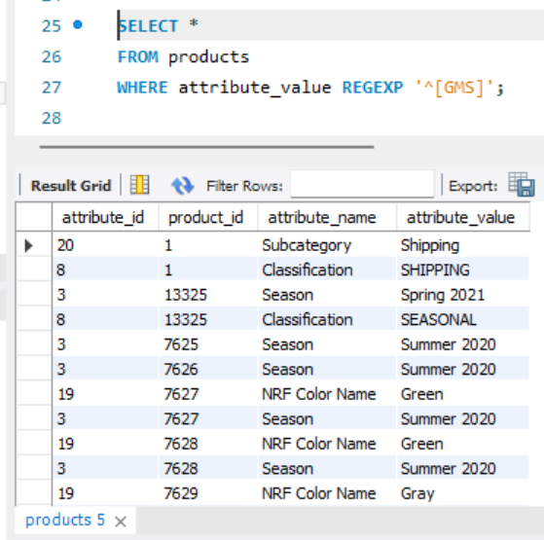
5. Find distinct attribute_values containing exactly 6 characters.
SELECT DISTINCT attribute_value
FROM products
WHERE attribute_value REGEXP '^.{6}$';
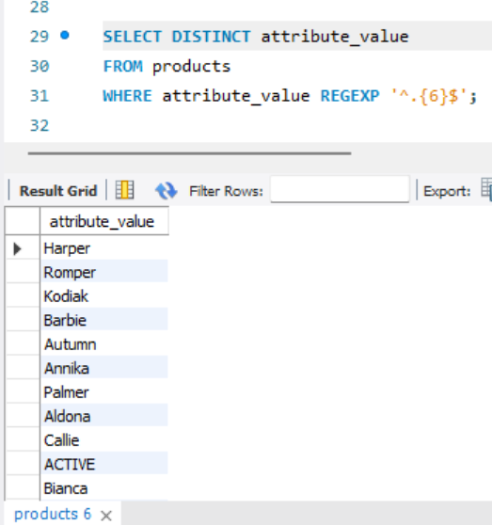
6. Find attibute_name records starting between A – D and the second letter between O – S and the rest of the letters can be anything.
SELECT *
FROM products
WHERE attribute_name REGEXP '^[A-D][O-S].*';
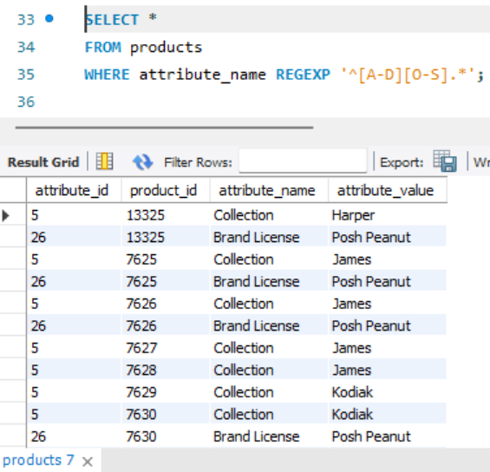
7. Find all records whose attribute_value contains only numeric values.
SELECT *
FROM products
WHERE attribute_value REGEXP '^[0-9]+$';
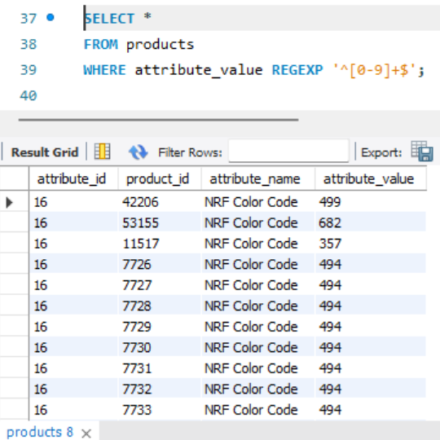
8. Extract distinct year values from the attribute_value column for Season attribute.
SELECT DISTINCT REGEXP_SUBSTR(attribute_value, '[0-9]{4}') AS year
FROM products
WHERE attribute_name = 'Season';
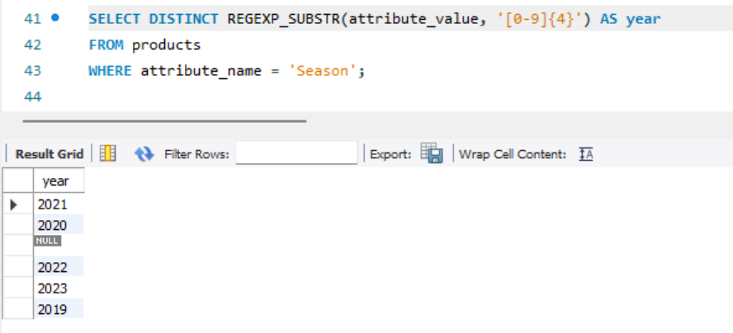
9. Find all records where attribute_value has more than 1 word for Collection attribute.
SELECT *
FROM products
WHERE attribute_name = 'Collection'
AND attribute_value REGEXP ' ';
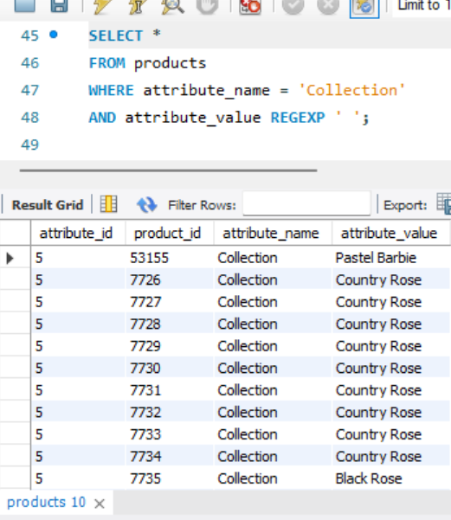
10. Write a query to produce the output in following columns,
attribute_value, is_date, is_numeric, is_alpha_numeric, is_text
- is_date is true if attribute_value contains the date format else false
- is_numeric is true if attribute_value contains only numbers format else false
- is_alpha_numeric is true if attribute_value contains numbers and characters/special characters else false
- is_text is true if attribute_value contains only characters else false
SELECT
attribute_value,
CASE
WHEN attribute_value REGEXP '^[0-9]{4}-[0-9]{2}-[0-9]{2}$' THEN TRUE
ELSE FALSE
END AS is_date,
CASE
WHEN attribute_value REGEXP '^[0-9]+$' THEN TRUE
ELSE FALSE
END AS is_numeric,
CASE
WHEN attribute_value REGEXP '^[A-Za-z0-9]+$'
AND attribute_value REGEXP '[0-9]'
AND attribute_value REGEXP '[A-Za-z]'
THEN TRUE
ELSE FALSE
END AS is_alpha_numeric,
CASE
WHEN attribute_value REGEXP '^[A-Za-z]+$' THEN TRUE
ELSE FALSE
END AS is_text
FROM products;
